DOCUMENTATION

By

Arbaz khan,Noman,Wahab ali

**ACKNOWLEDGMENT**

We are really grateful because we managed to complete our E-project within the time given by our teacher **Sir Amjad**. This assignment cannot be completed without the effort and co-operation from our group members, Group members; Arbaz khan,Noman,Wahab ali

We also sincerely thank our teacher **Sir Amjad** for the guidance and encouragement in finishing this project and also for teaching us in this course.

Last but not the least, we would like to express our gratitude to our friends and respondents for the support and willingness directly or indirectly to spend some times with us to fill in the questionnaires.

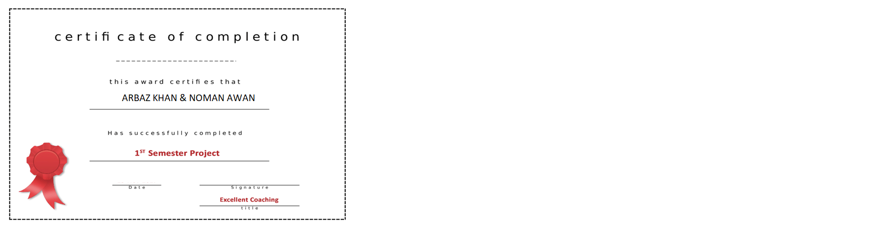

**CONTENT**

1. Introduction------------------------------------------------- 5
2. Objectives of the Project-------------------------------7
3. Topic of our Project--------------------------------------- 8
4. Hardware/Software Requirements------------------ 9
5. Work Analysis----------------------------------------------- 10
6. Design -------------------------------------------------------- 11
7. Homepage ------------------------------------------------- 12
8. Header -------------------------------------------------------- 15
9. Navigation Bar ---------------------------------------------- 17
10. Slider ---------------------------------------------------------- 18
11. Courses ------------------------------------------------------ 19
12. Footer -------------------------------------------------------- 25
13. Contact Us ------------------------------------------------- 26
14. Flowchart for Contact Us -------------------------------- 29
15. Faculty ------------------------------------------------------- 31
16. Fees ----------------------------------------------------------- 33
17. About Us ---------------------------------------------------- 36

1. **Introduction**

The thirst for learning, upgrading technical skills and applying the concepts in real life environment at a fast pace is what the industry demands from IT professionals today. However busy work schedules, far-flung locations, unavailability of convenient time-slots pose as major barriers when it comes to applying the concepts into realism. And hence the need to look out for alternative means of implementation in the form of laddered approach.

The above truly pose as constraints especially for our students too! With their busy schedules, it is indeed difficult for our students to keep up with the genuine and constant need for integrated application which can be seen live especially so in the field of IT education where technology can change on the spur of a moment. *Well, technology does come to our rescue at such times!!*

Keeping the above in mind and in tune with our constant endeavour to use Technology in our training model, we at Aptech have thought of revolutionizing the way our students learn and implement the concepts using tools themselves by providing a *live and synchronous EProject learning environment!*

**So what is this EProject?**

EProject is a step-by-step learning environment that closely simulates the classroom and Lab based learning environment into actual implementation. It is a project implementation at your fingertips!! An electronic, live juncture on the machine that allows you to

* Practice step by step i.e. laddered approach.
* Build a larger more robust application.
* Usage of certain utilities in applications designed by user.
* Single program to unified code leading to a complete application.
* Learn implementation of concepts in a phased manner.
* Enhance skills and add value.
* Work on real life projects.
* Give a real life scenario and help to create applications more complicated and useful.
* Mentoring through email support.

The students at the centre are expected to complete this EProject and send complete project along with the documentation to EProjects Team

Looking forward to a positive response from your end!!

* Single program to unified code leading to a complete application.
* Learn implementation of concepts in a phased manner.
* Enhance skills and add value.

1. **Objectives of the project**

The Objective of this program is to give a sample project to work on real life projects. These applications help you build a larger more robust application.

The objective is not to teach you HTML/JavaScript/Dreamweaver/HTML5 but to provide you with a real life scenario and help you create basic applications using the tools.

You can revise the chapters before you start with the project.

This project is meant for students who have completed the module of ***Dreamweaver***. These programs should be done in the Lab sessions with assistance of the faculty if required.

It is very essential that a student has a clear understanding of the subject. Students should go through the project and solve the assignments as per requirements given.

Kindly get back to EProjects Team in case of any doubts regarding the application or its objectives.

**Topic of Our Project**

**BIO GRAPHY WEBSITE**

**Problem Statement**

A biography is a detailed description of a person's life. It involves more than just the basic facts like education, work, relationships, and death; it portrays a person's experience of these life events. Unlike a profile or [curriculum vitae](https://en.wikipedia.org/wiki/Curriculum_vitae) ([résumé](https://en.wikipedia.org/wiki/R%C3%A9sum%C3%A9)), a biography presents a subject's life story, highlighting various aspects of their life, including intimate details of experience, and may include an analysis of the subject's personality.

You need to develop a biography of any **Nobel prize winner** in **science genre**.

The website is to be developed for the Windows Platform using HTML5, JavaScript and Geolocation. The site should work well in all leading browsers including Chrome, IE, Firefox etc.

**Requirement Specification:**

The Web site is to be created based on the following requirements.

1. The Home Page should be created making use of Sections with a suitable logo, the header section can be added which will show images chairs.
2. The site must contain the links to navigate through any category for the information.
3. The site should include the complete personal details about the respective person
4. User should also be able to get the glimpse of education and carrier.
5. There should be carrier graph and struggle of the person
6. One should be able to get to know the complete details about the achievements.
7. There should also be a section that includes the details specifying research/experiment for which Nobel prize was awarded.
8. There should be a section where one can get to know the available books related to him/her
9. A brief summary of about the research should be available on the Website which can be downloaded by the User who wishes to.
11. **Hardware/ Software Requirements**

**Hardware**

* A minimum computer system that will help you access all the tools in the courses is a Pentium 166 or better
* 64 Megabytes of RAM or better

**Software**

* Notepad/HTML editor
* Dreamweaver
* IE 5.0/ Netscape 6.0

1. **WORK ANALYSIS**

|  |  |  |
| --- | --- | --- |
| Task | Arbaz Khan | Noman |
| Analysis |  |  |
| Design |  |  |
| Coding |  |  |
| Testing |  |  |
| Documentation |  |  |

1. 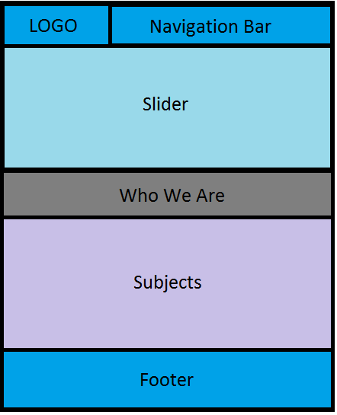**DESIGN**

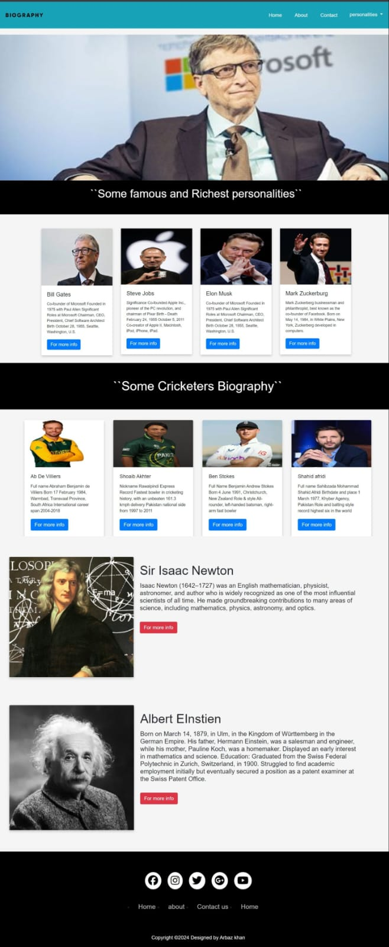

Home Page

**HTML**

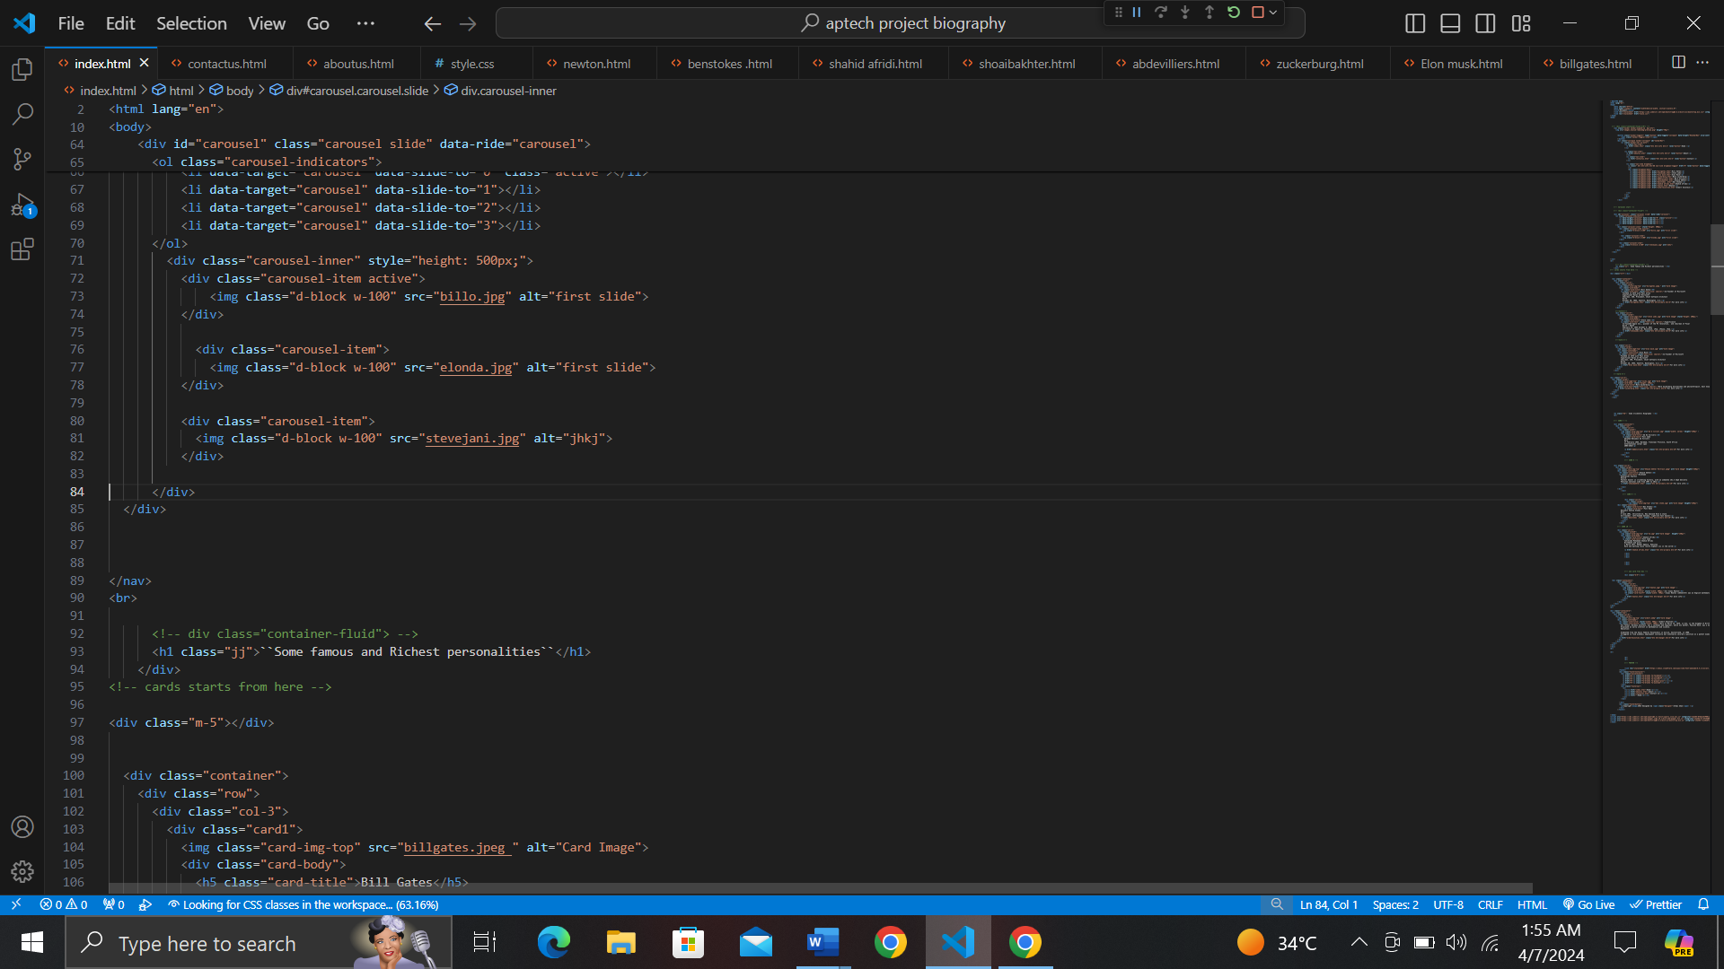

**CSS**

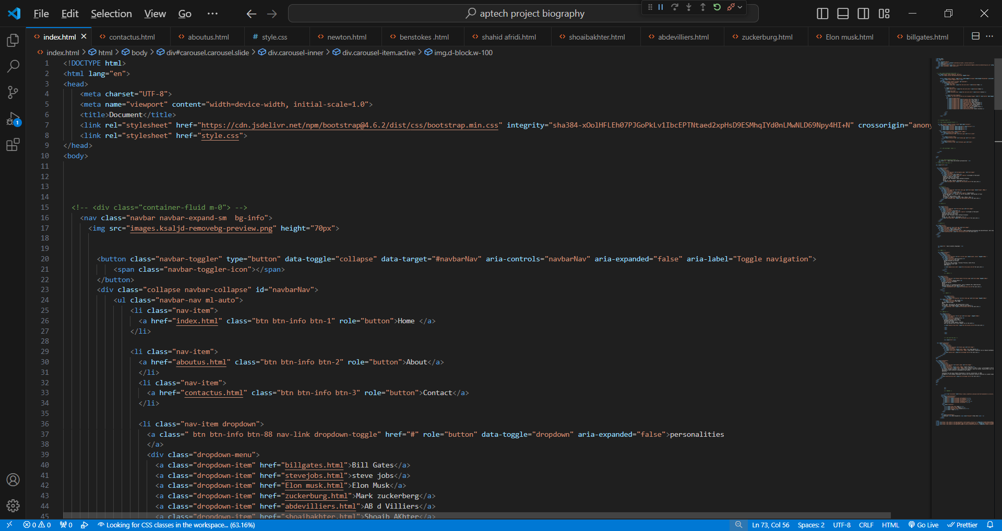

* + 1. **Header**



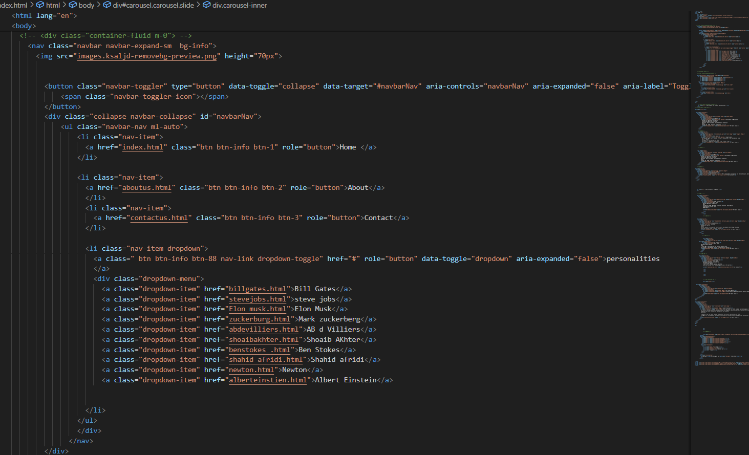

**CSS**

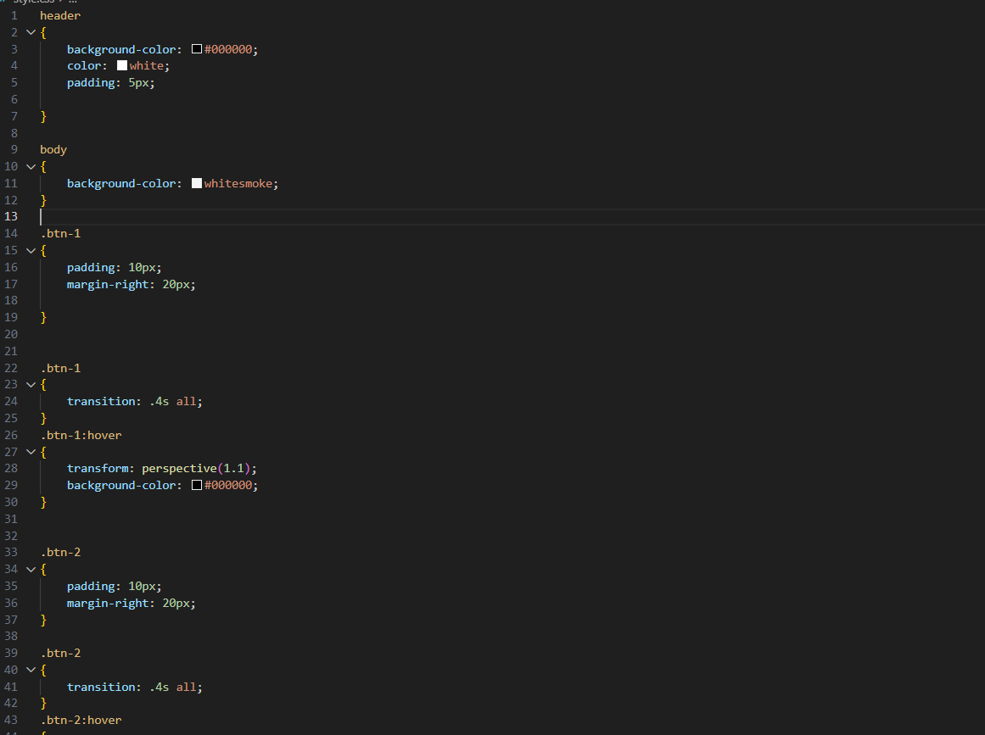



**NAVIGATION BAR**

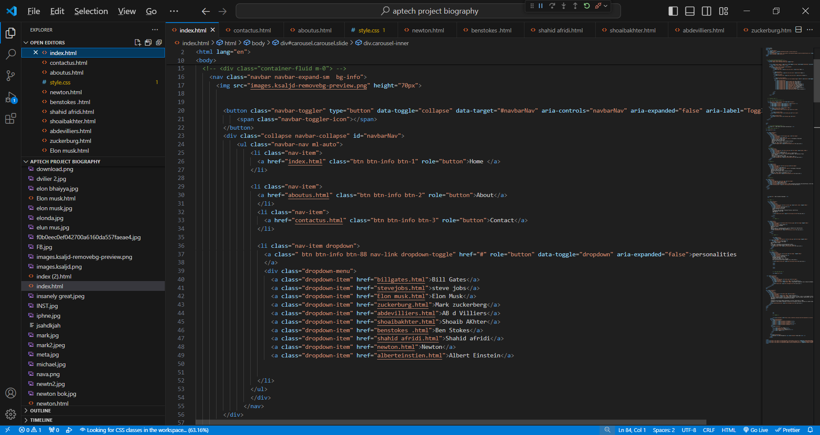**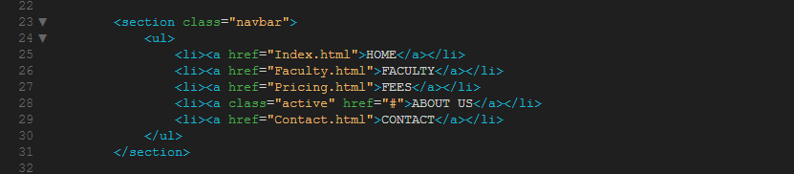HTML**

**CAROUSEL**

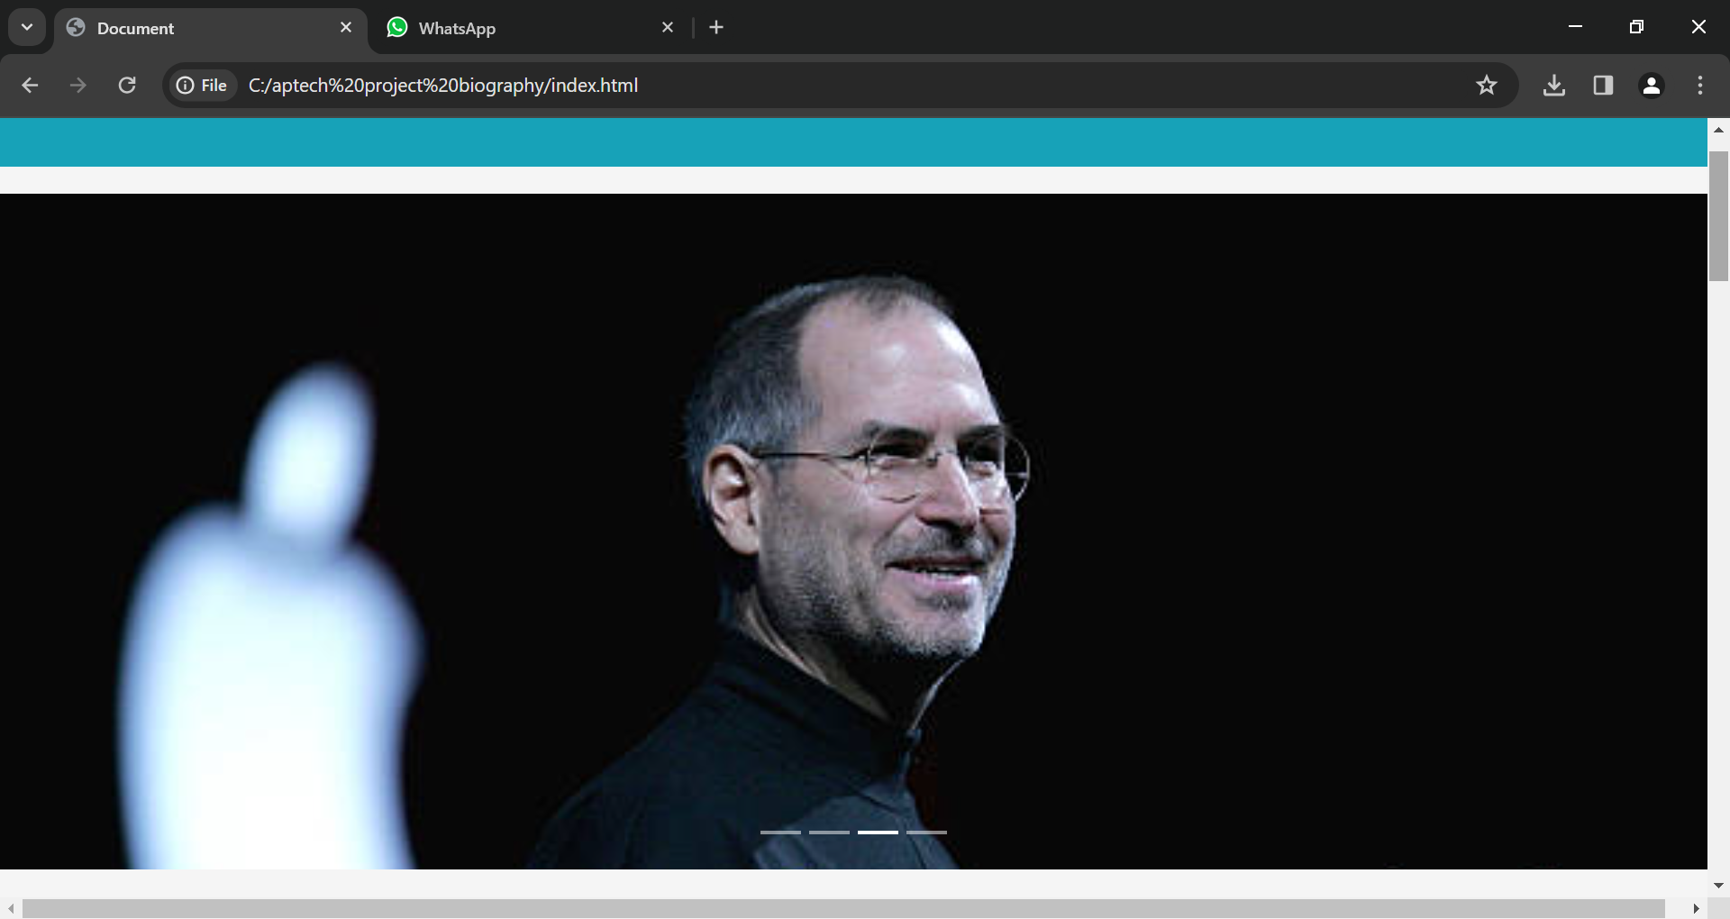

**HTML**

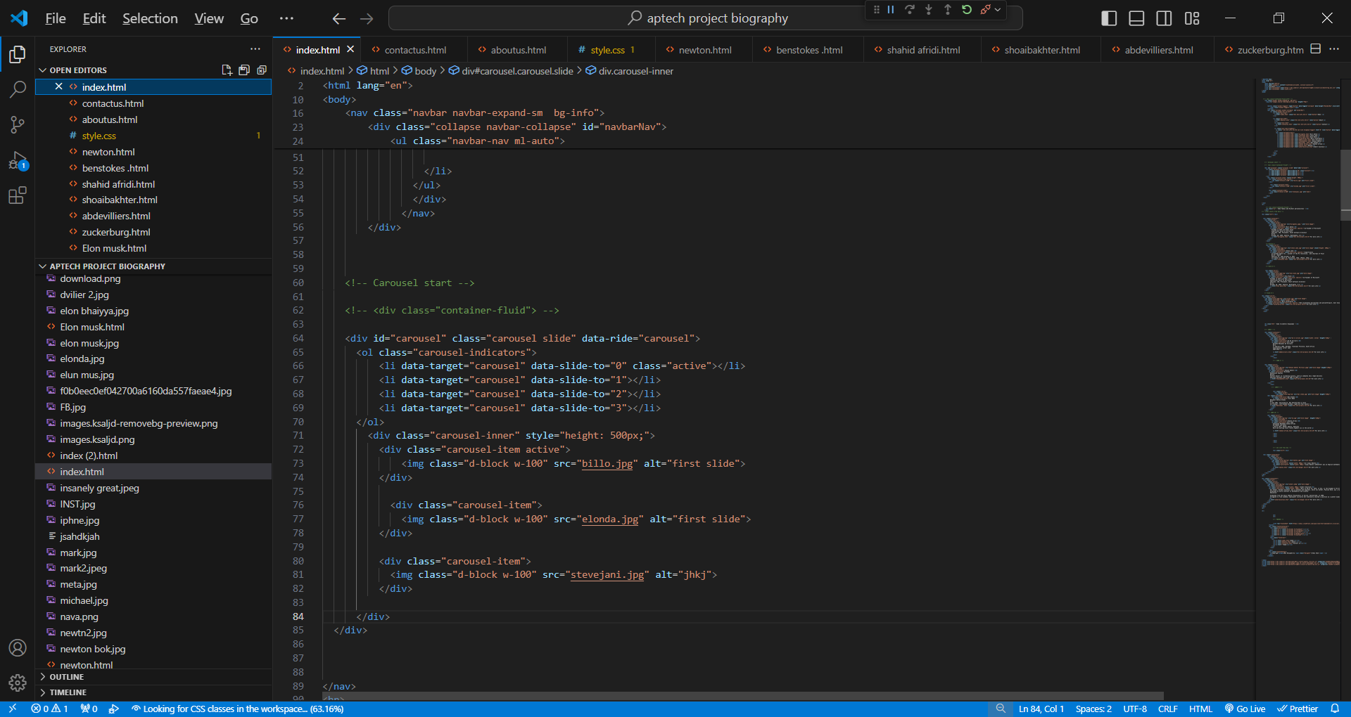

**CSS**

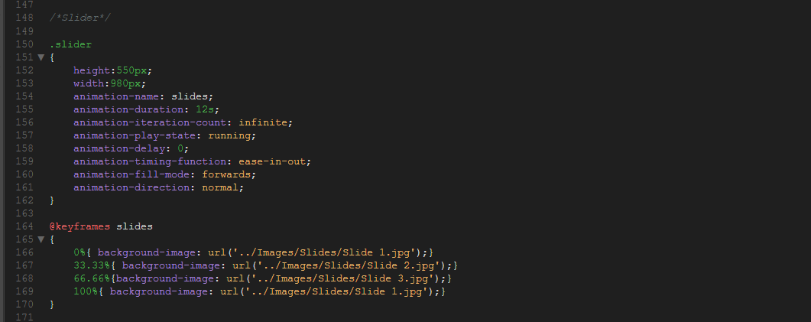

**CARDS**

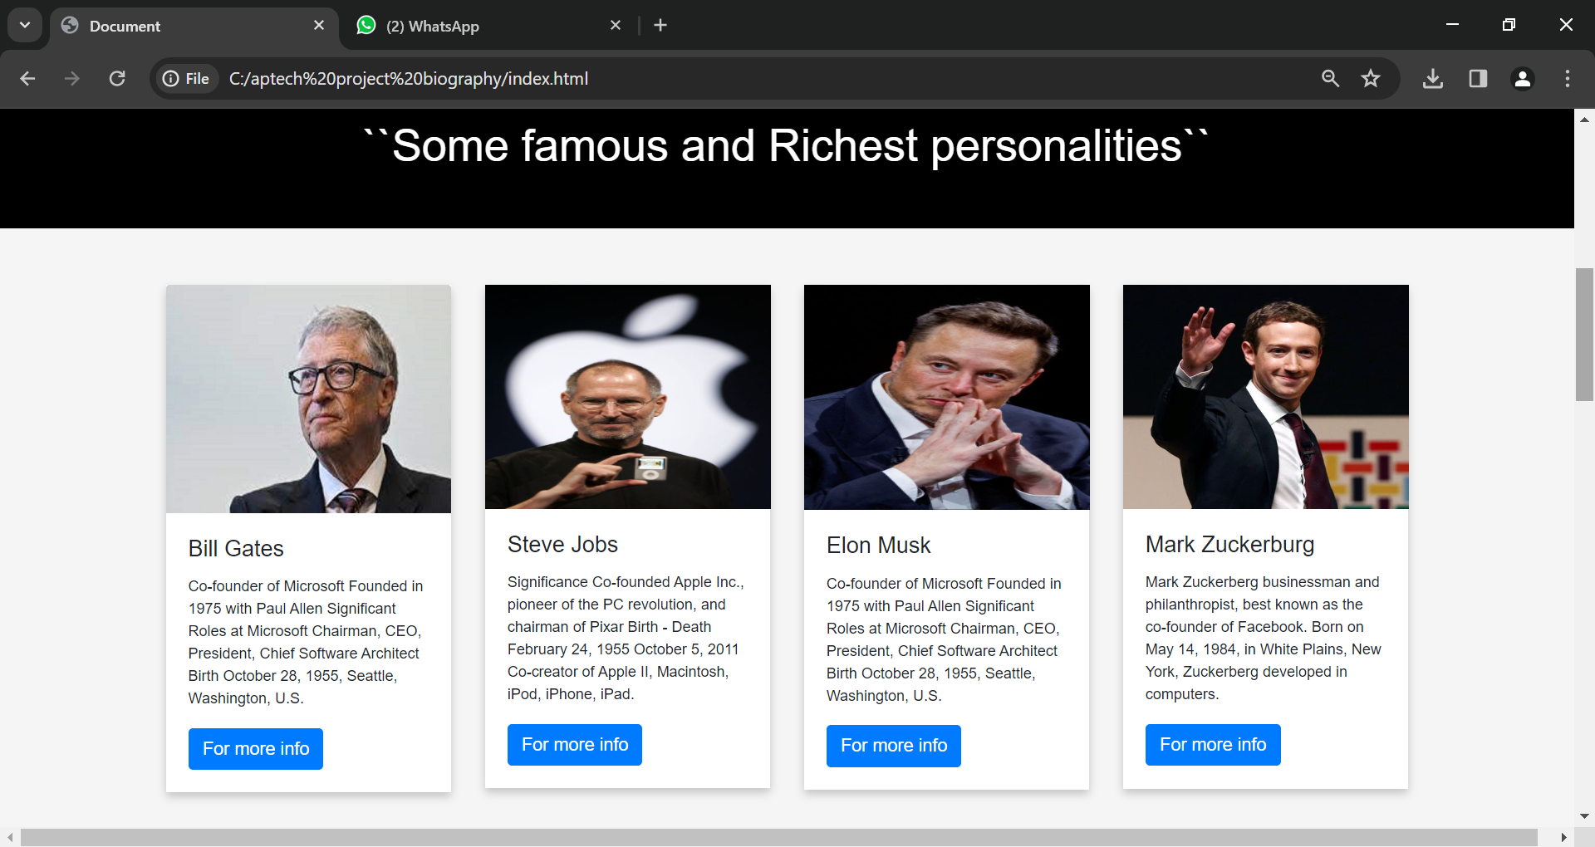

**HTML**

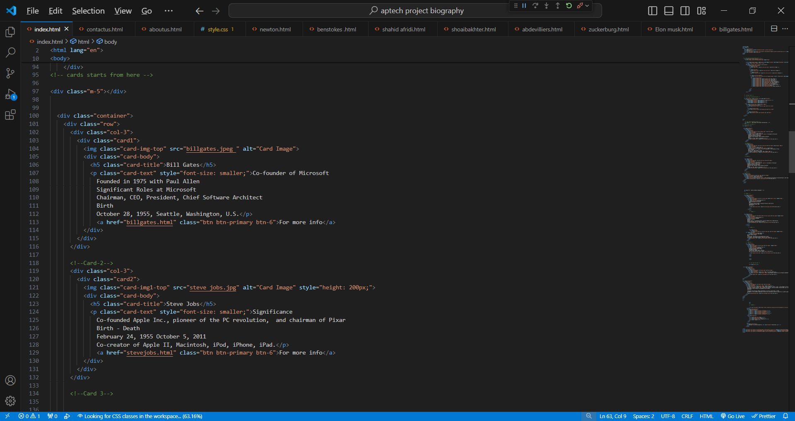

**CSS**

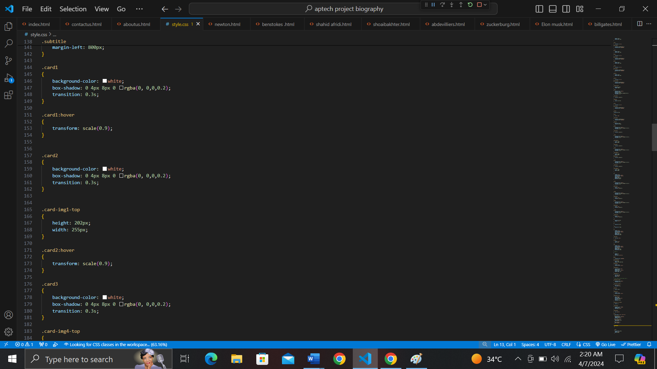

1. **Footer**



**HTML**

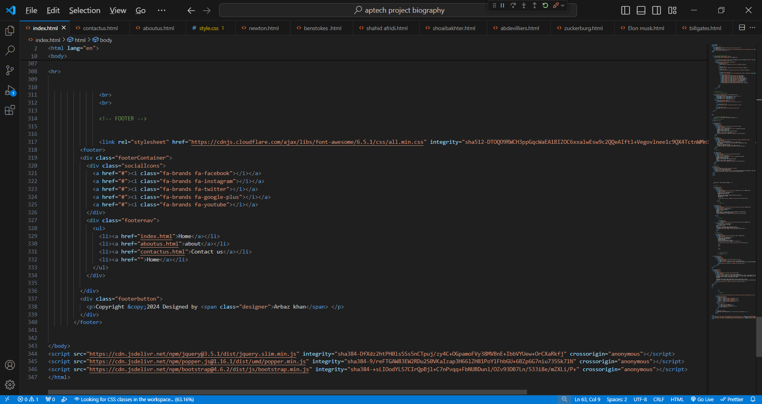

**CSS**

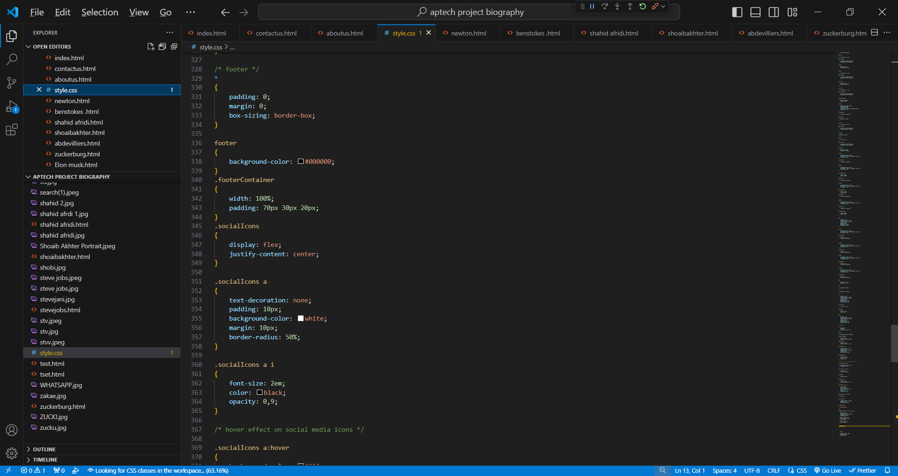

**ABOUT US PAGE**

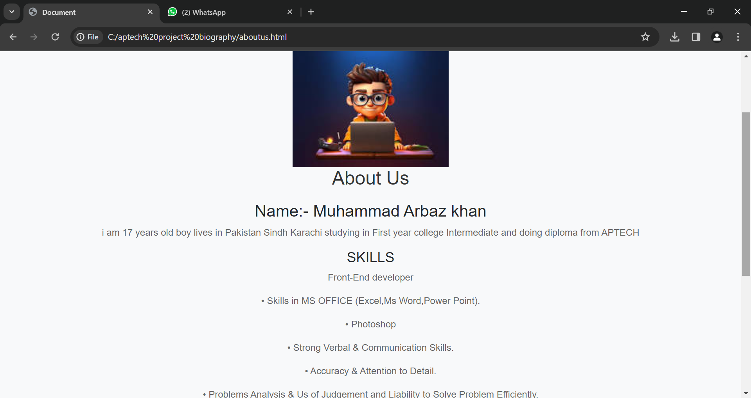

**HTML**

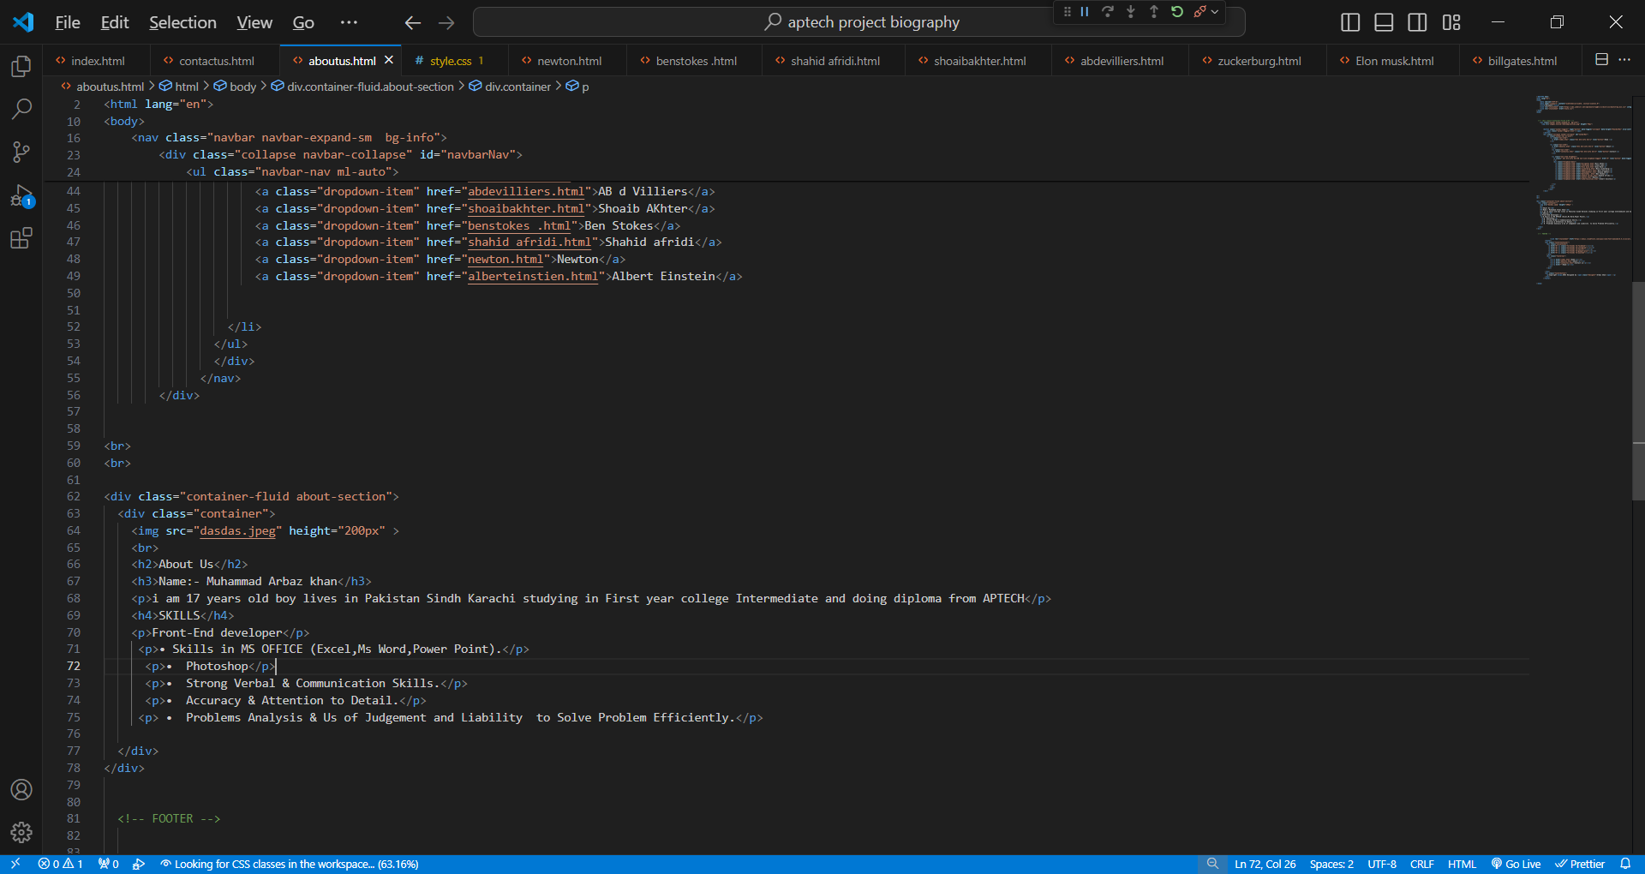

**CSS**

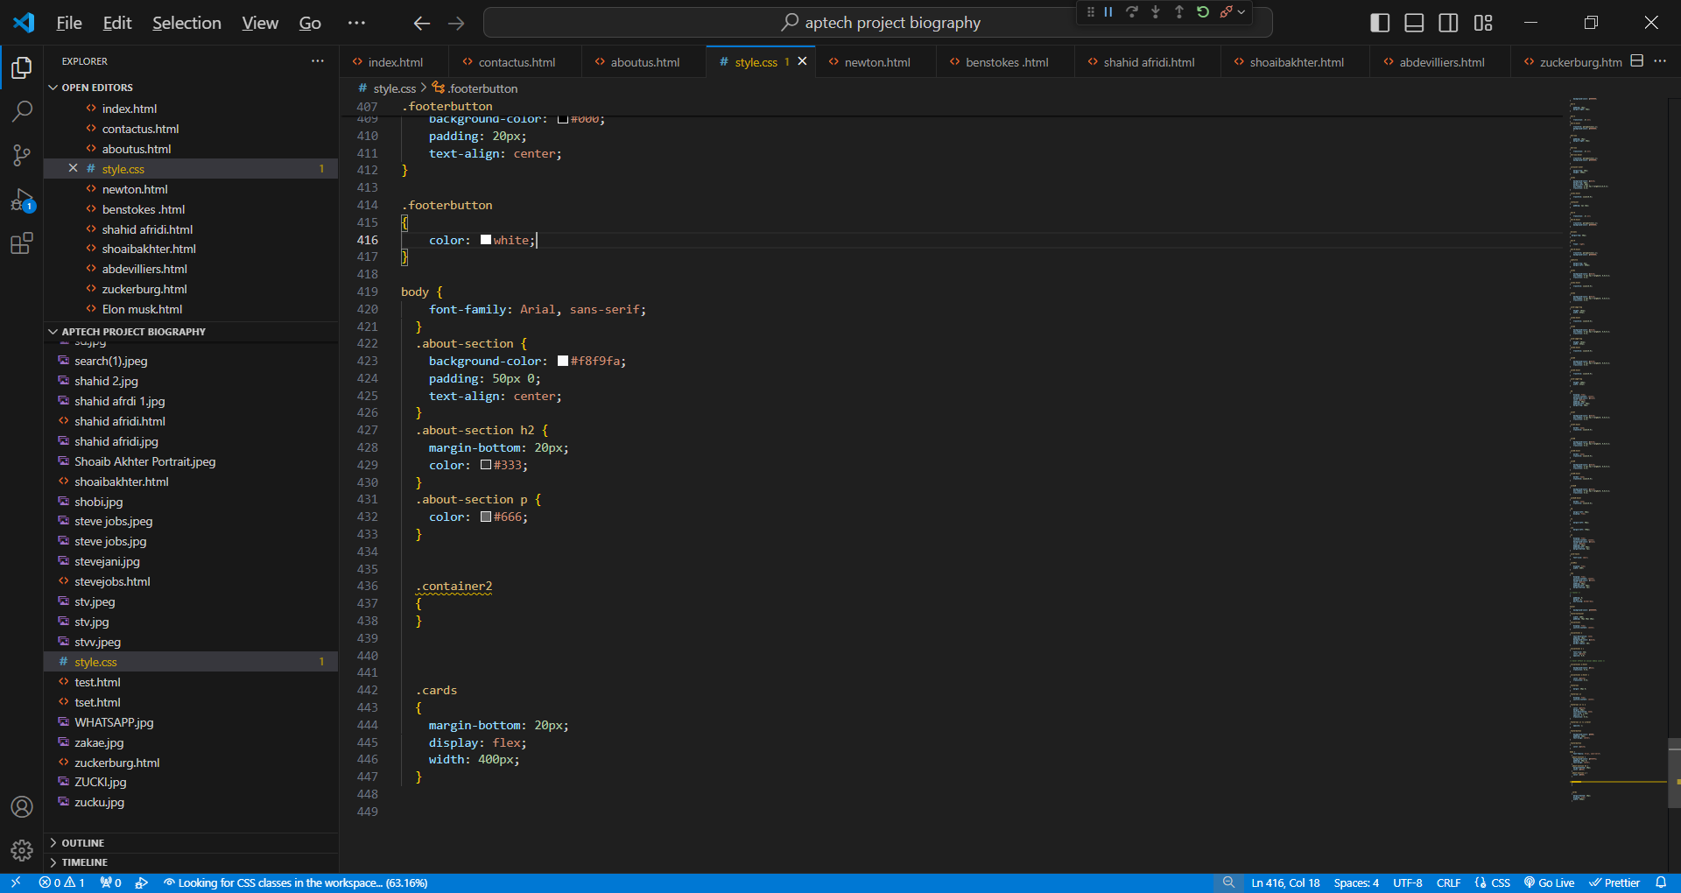

**CONTACTS US PAGE**

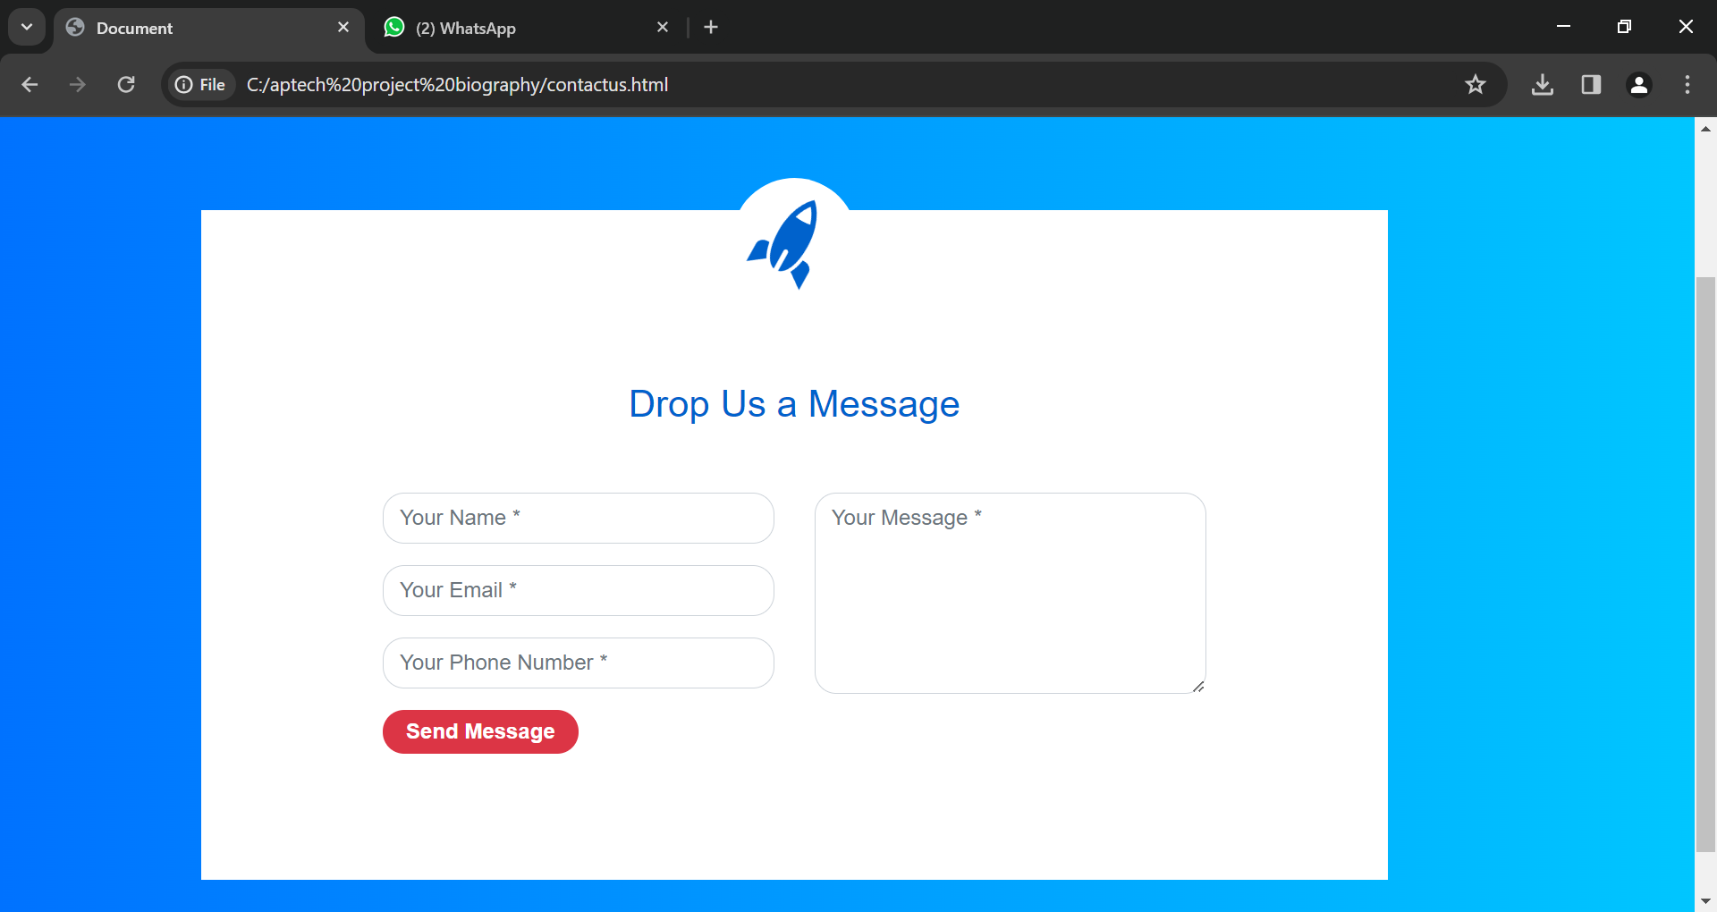

**HTML**

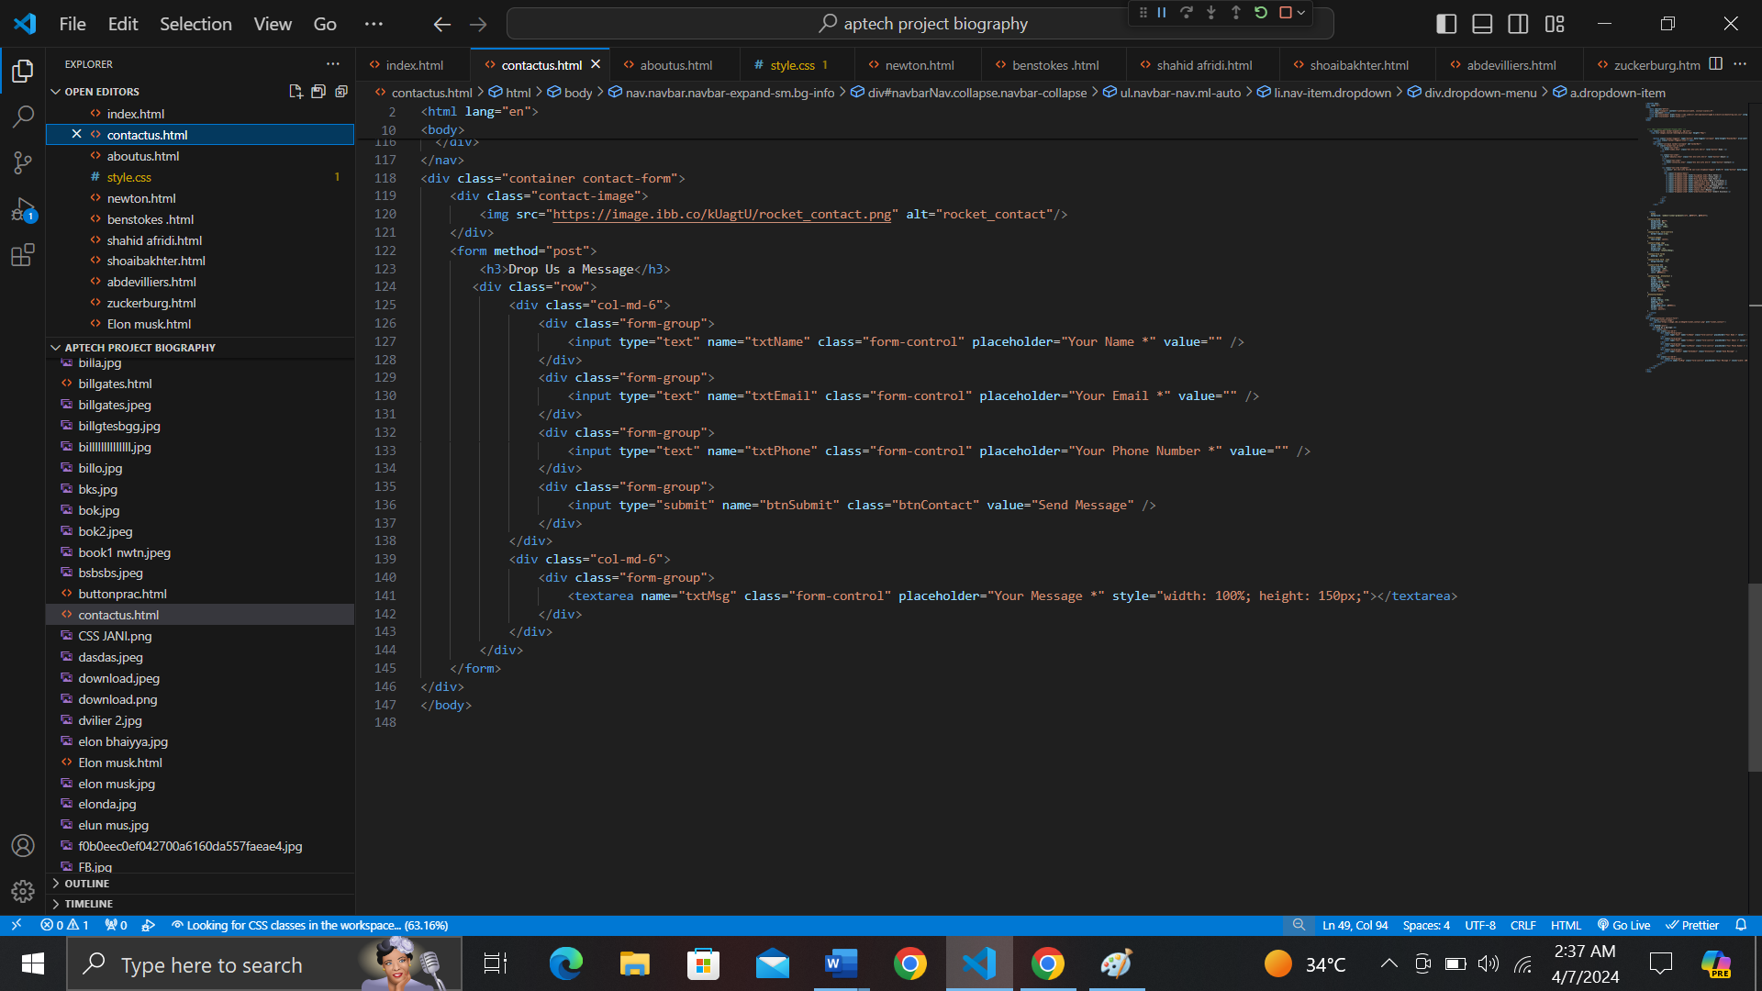

**CSS**

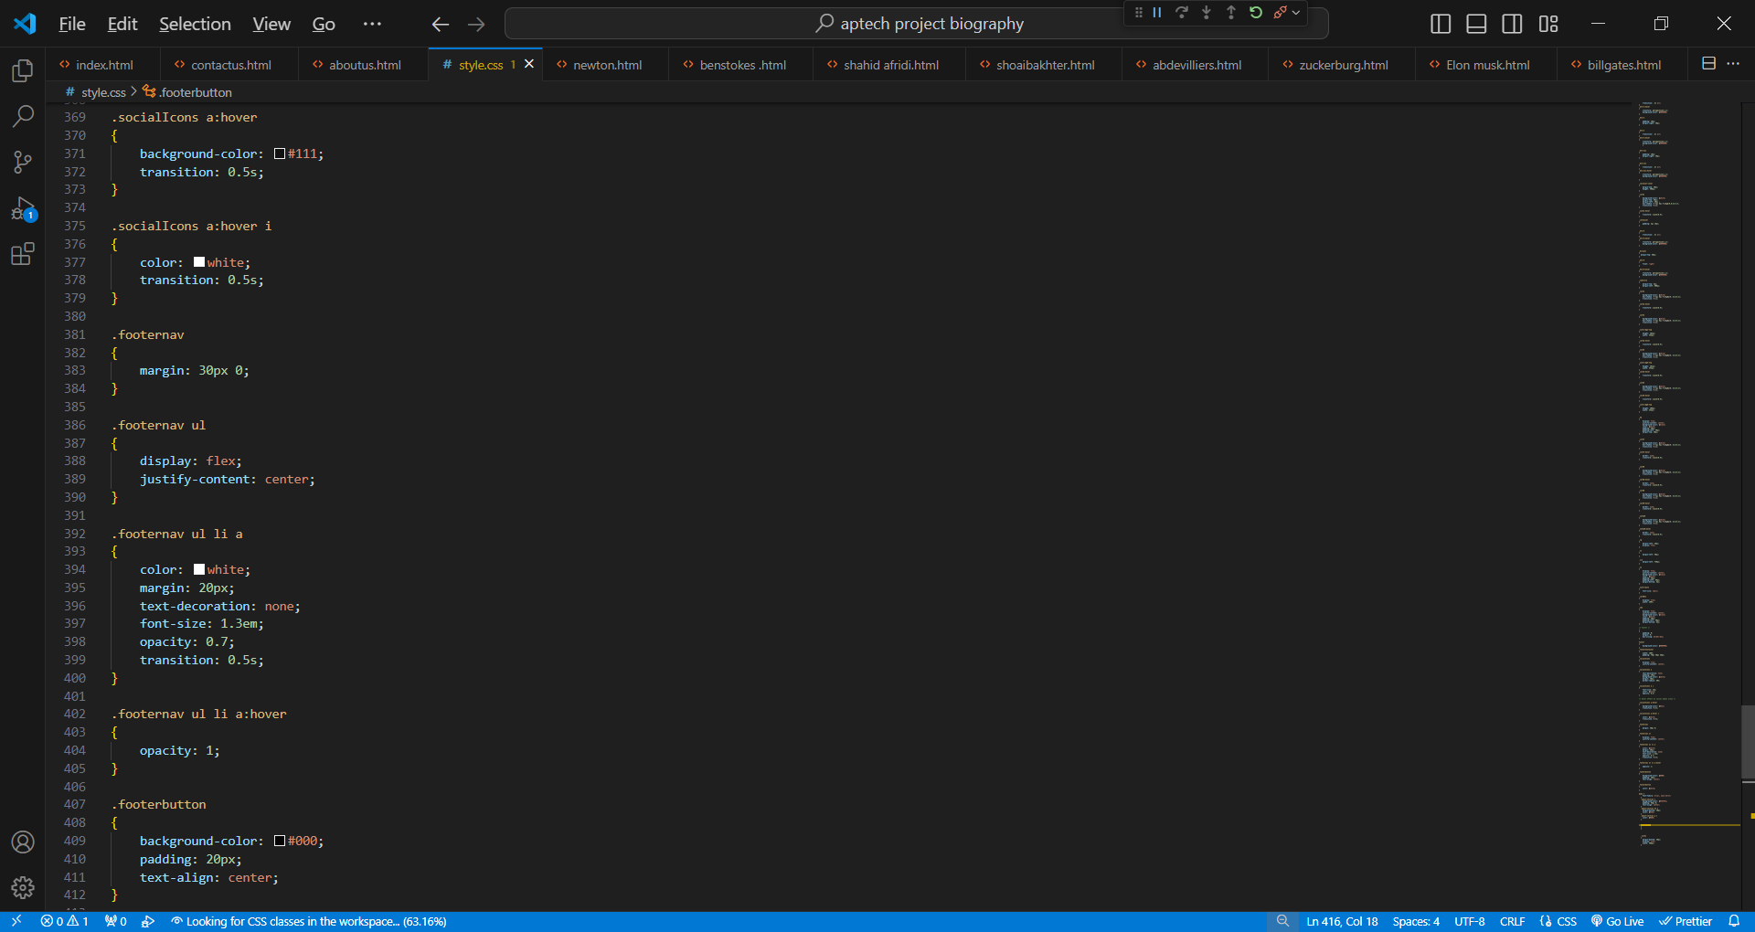

THANK YOU